**Fanka Shundovska**

**IntelliJ – Selenium POM Homework – First Name and Last Name**

1. The following homework will include creating new project and importing all dependencies. The project name will be Selenium-Homework-FirstName and Last Name.
2. We will need to create 3 tests using the POM (Page Object Model) as follows:
3. On the following link: https://demoqa.com/links under category **Following links will send an api calls** click all links and assert all messages that they display for each link.
4. On the following link: https://demoqa.com/login we will need a data provider with 5 arrays (meaning populate the fields username and password with different values) to insert username, password, click login and verify the message **Invalid Username or Password**.
5. On the same link we need another data provider with 5 arrays (meaning populate the fields with 5 different values) to click New User, populate firstname, lastname, username, password, click register and assert the message **Please Verify Recaptcha to register.**

**Note**: Upload the homework as a zip file (Exported Intellij project: File -> Export -> Project to zip file)

**LoginPage**

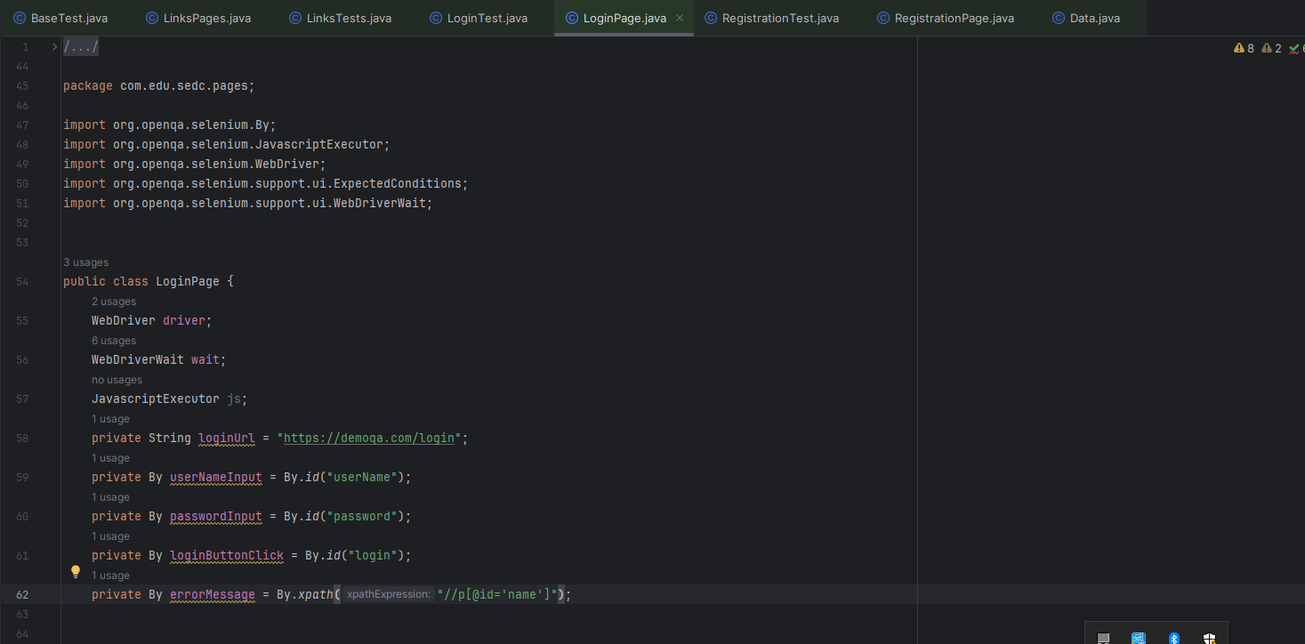

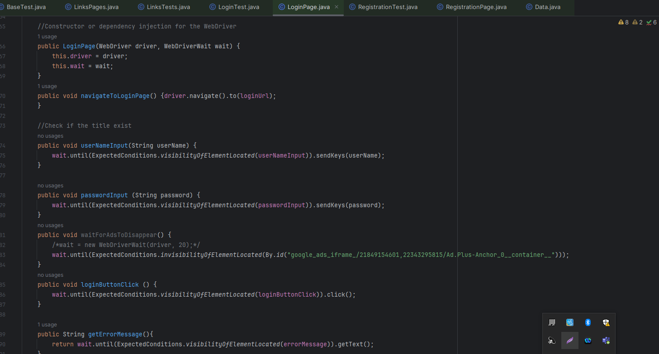

**LoginTest**

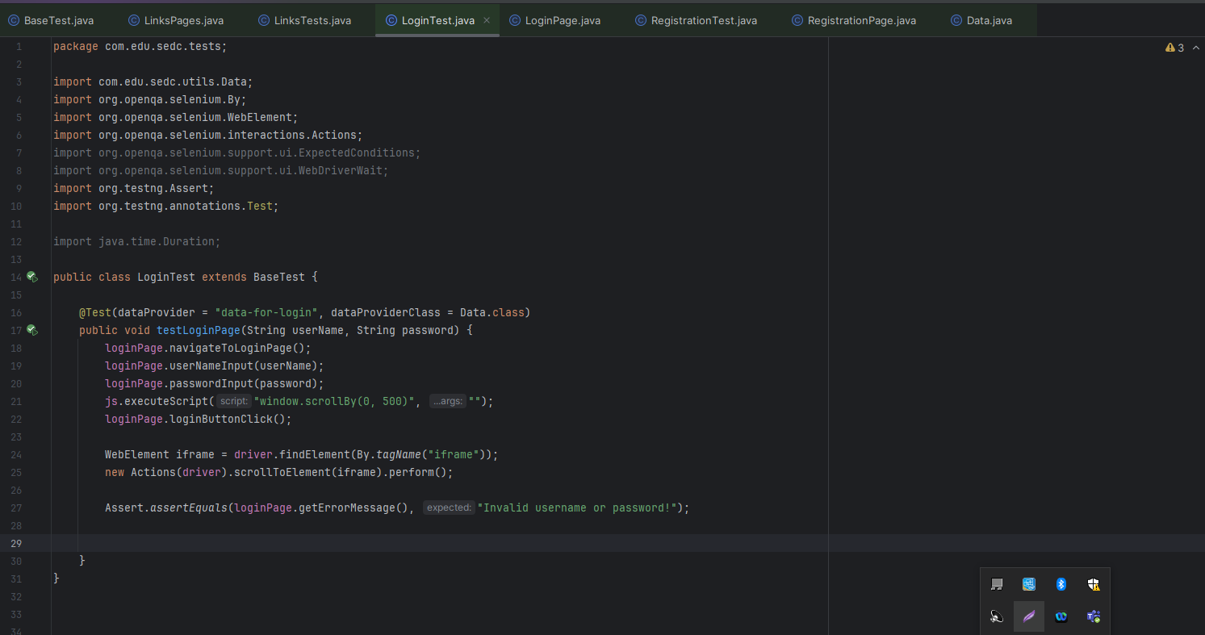

**LinksPages**

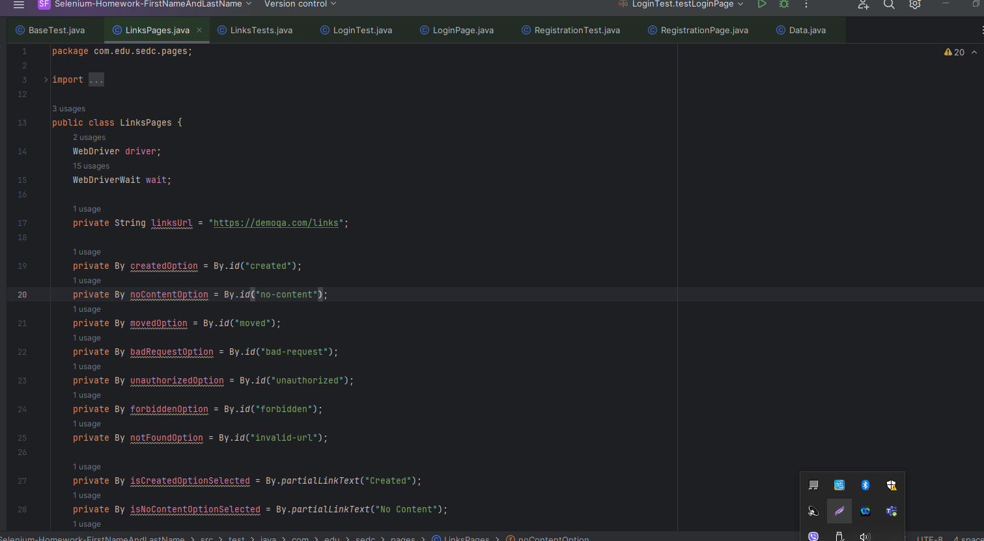

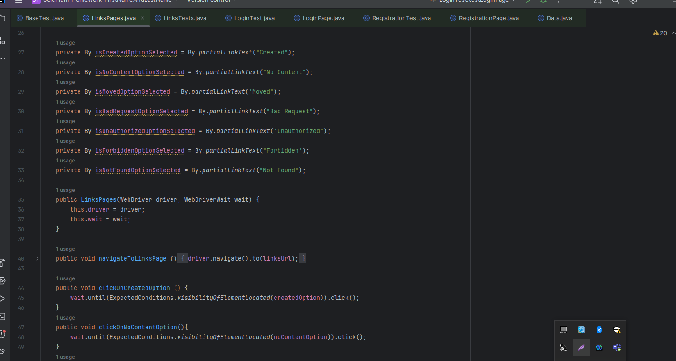

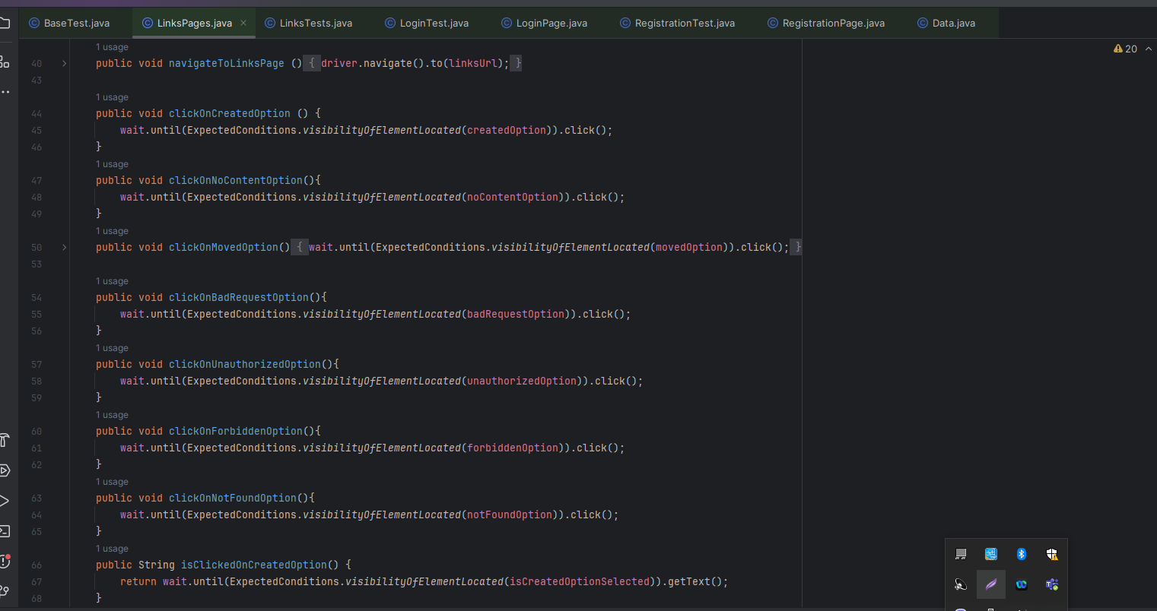

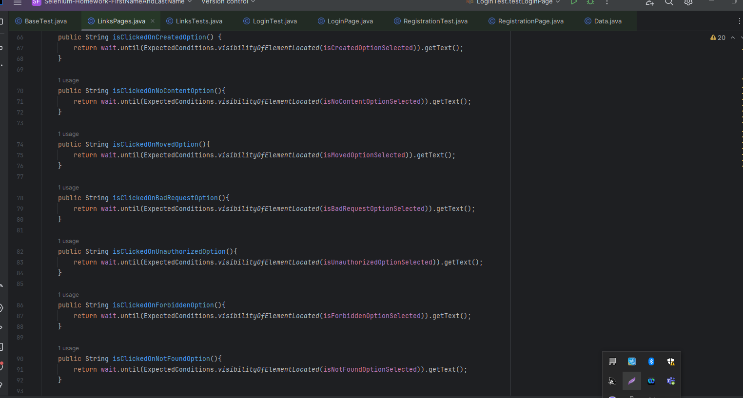

**LinksTests**

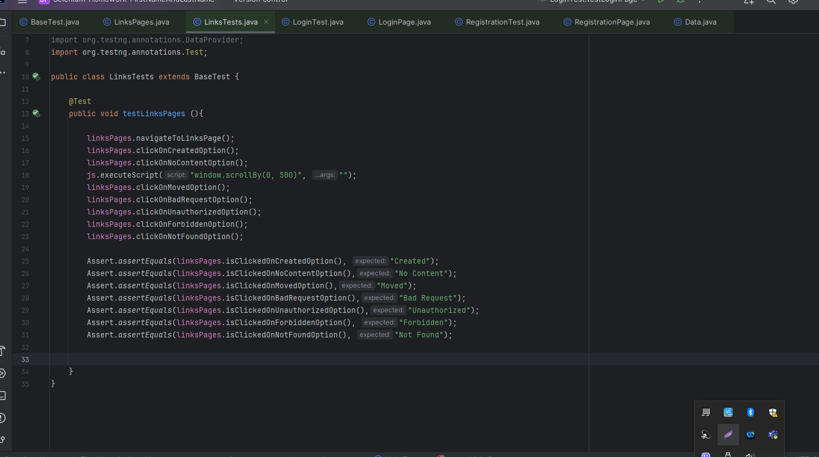

**RegisterPage**

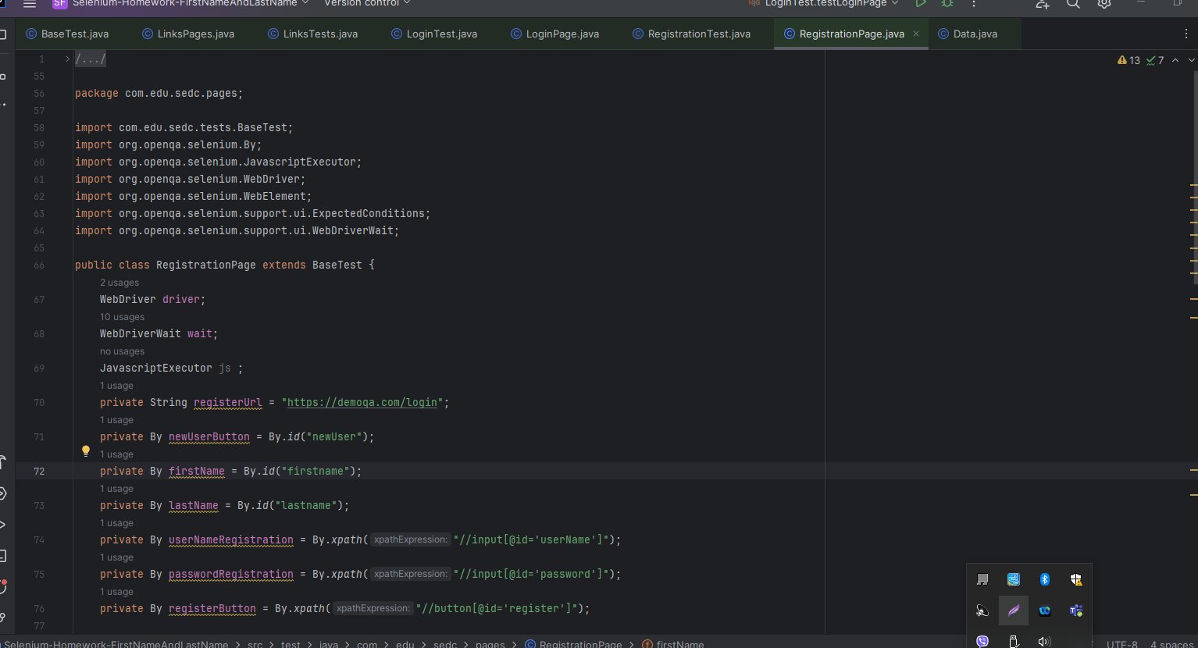

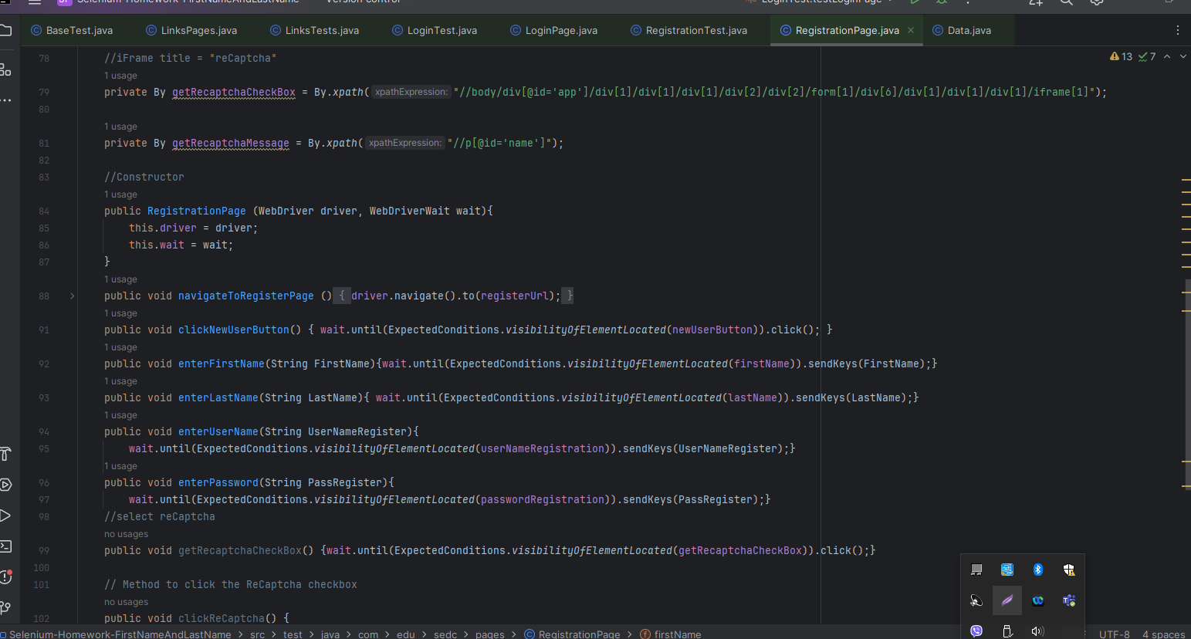

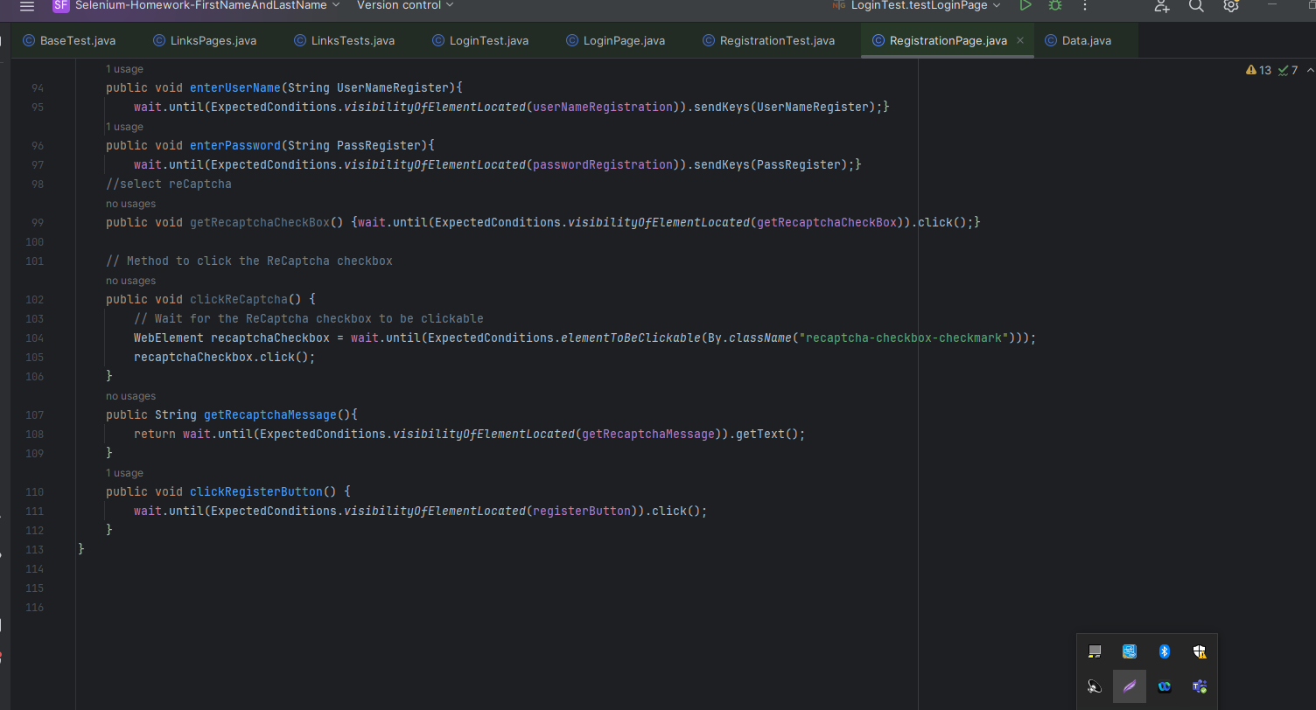

**RegistrationTest**

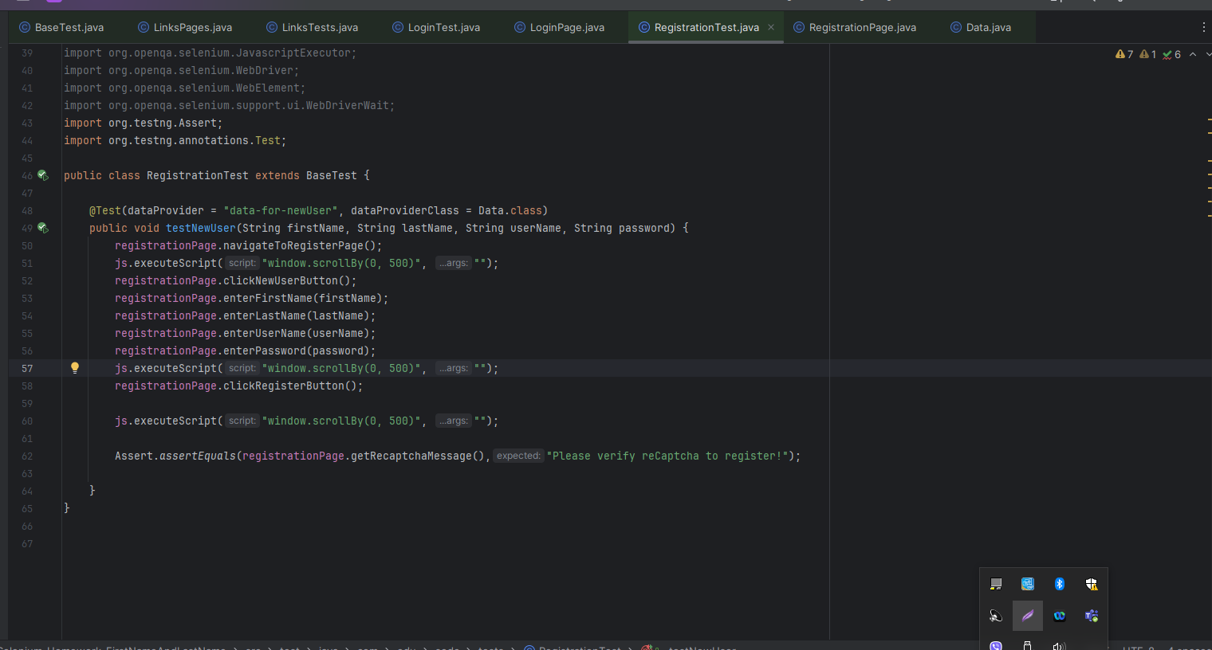

**BaseTest**

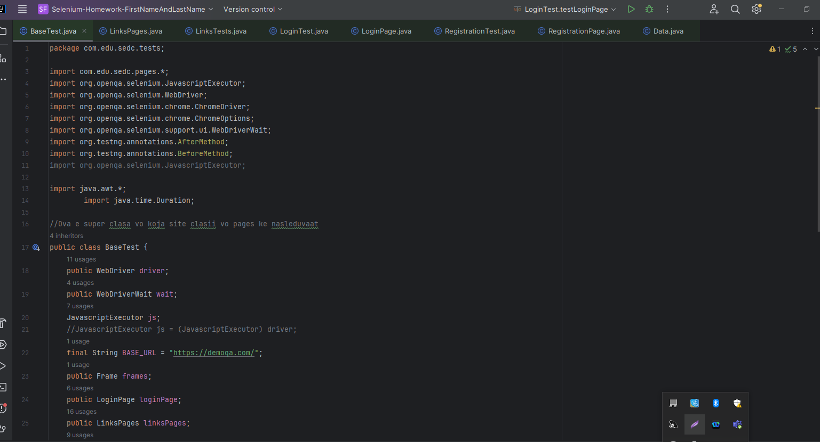

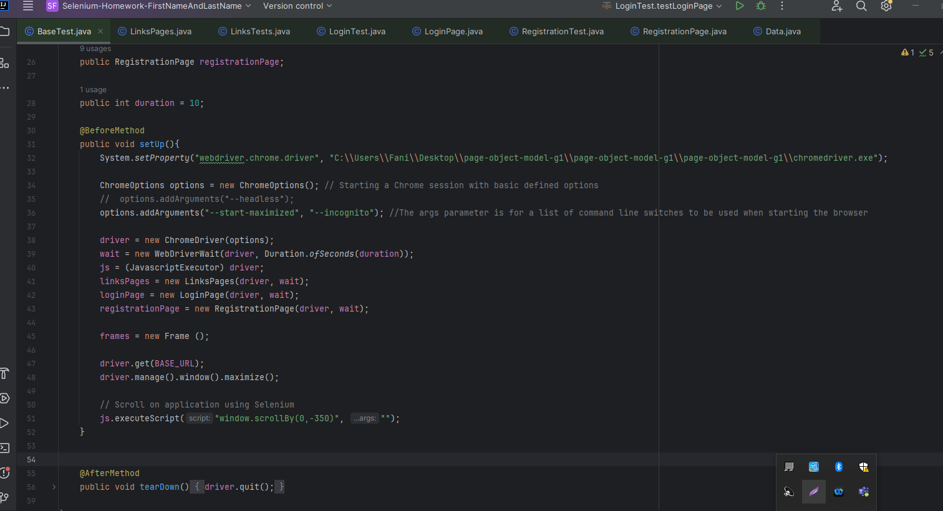

**Data**

